` 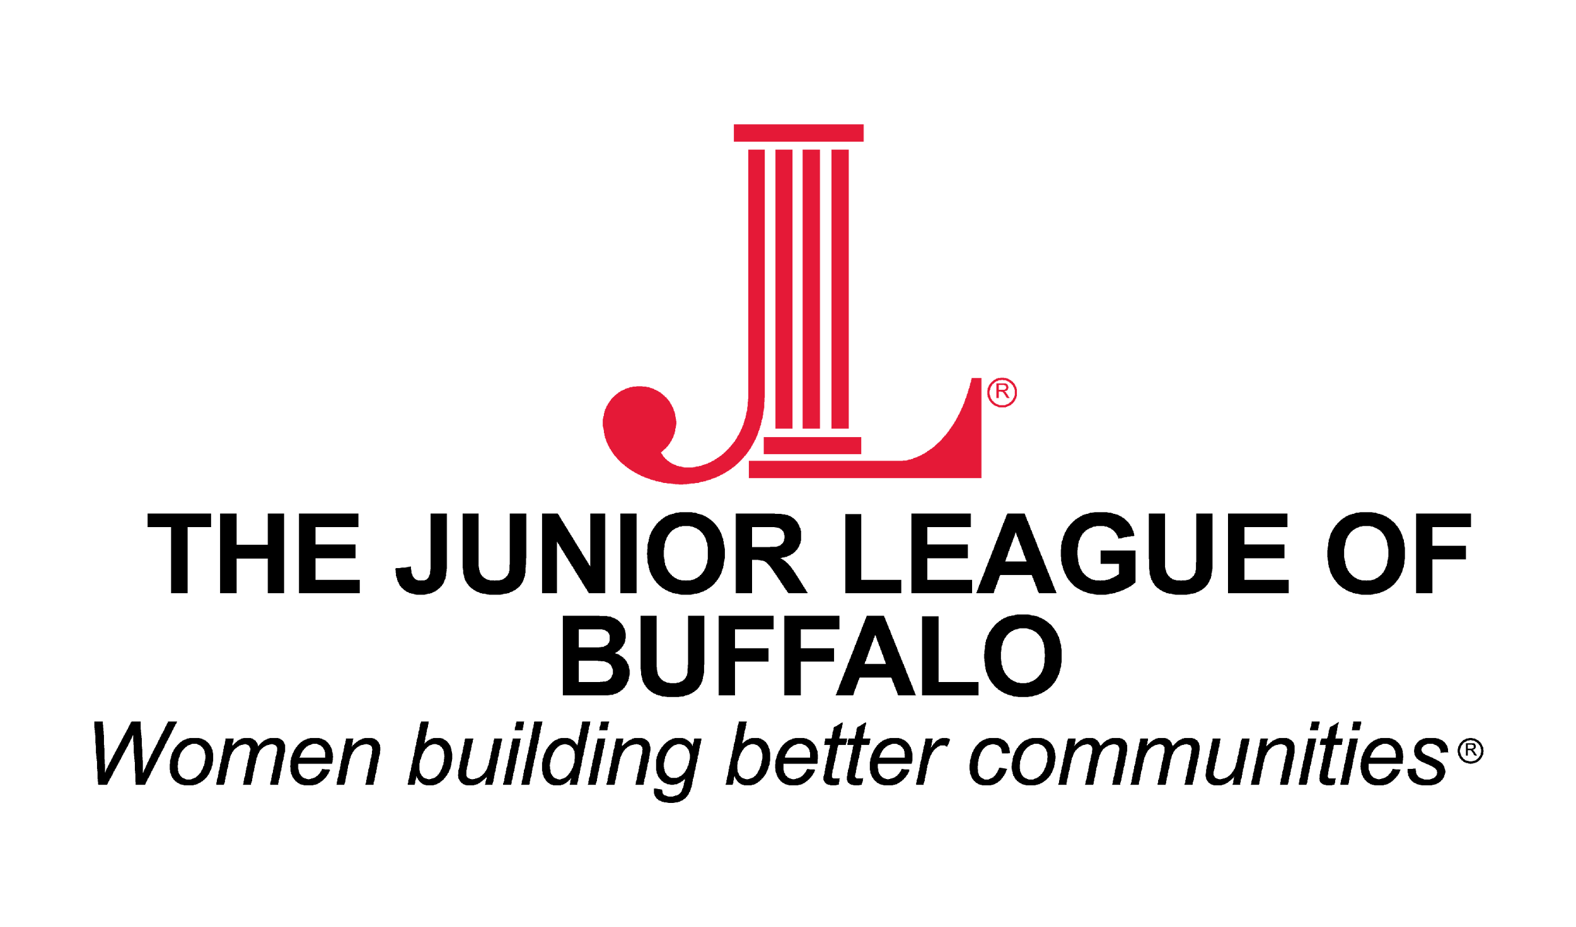
SCHOLARSHIP APPLICATION
For Female High School Seniors Only
Graduating Class of 2025
Application Deadline ~ FEB 27, 2026

Junior League of Buffalo High School Scholarship
Are you a female high school senior graduating in the class of 2026? The Junior League of Buffalo invites you to apply for one of three, two-thousand-dollar ($2,000) scholarships to be given to your post-high school educational institution to defray expenses for tuition, books, fees, or dormitory.

The selection of recipients is based on evidence of demonstrated community service and volunteerism within their school and community. Additionally, the student’s background should show strong evidence of being well-rounded in personal and academic endeavors.

Qualifications: Applicants must be a female student attending an Erie, Niagara, Orleans, Genesee, Wyoming, Chautauqua, Cattaraugus, or Allegany County high school, Class of 2026, who plans to attend a two or four-year accredited college beginning in the Fall of 2026. Immediate family members of Junior League of Buffalo members are not eligible for consideration.
ALL INFORMATION MUST BE TYPED OR NEATLY PRINTED ON THE APPLICATION. PLEASE SUPPORT OUR EFFORT TO GO GREEN BY RETURNING THIS APPLICATION VIA EMAIL TO: BROOKESMITH716@GMAIL.COM

INCOMPLETE INFORMATION OR ADDITIONAL PAGES WILL DISQUALIFY THIS APPLICATION.

SECTION A. To be filled out by the applicant.

Student Name_________________________________________________Phone________________________

Address_____________________________________________City________________________Zip_______

Email Address ____________________________________________________________________________

High School Name_________________________________________________________________________

Guidance Counselor _______________________________________________________________________

Cumulative Grade Point Average _____________________________________________________________

College Attending/Applied ___________________________________________________________________

________________________________________________________________________________________

Interest of Study __________________________________________________________________________

Are you a relative by blood or marriage to any member or employee of the Junior League of Buffalo? _______Yes_______No If yes, you may not apply for this scholarship.

Page 1 of 6

Are you currently employed? _______Yes _______No If yes, how many hours per week?

If yes, please describe (tutoring, baby-sitting, restaurant, retail, etc.)

________________________________________________________________________________________

________________________________________________________________________________________

________________________________________________________________________________________

________________________________________________________________________________________

________________________________________________________________________________________

Please list your extracurricular activities including the years in which you were involved.

________________________________________________________________________________________

________________________________________________________________________________________

________________________________________________________________________________________

________________________________________________________________________________________

________________________________________________________________________________________

________________________________________________________________________________________

________________________________________________________________________________________

________________________________________________________________________________________

________________________________________________________________________________________

________________________________________________________________________________________

________________________________________________________________________________________

________________________________________________________________________________________

________________________________________________________________________________________

________________________________________________________________________________________

________________________________________________________________________________________

________________________________________________________________________________________

________________________________________________________________________________________

________________________________________________________________________________________

________________________________________________________________________________________
Page 2 of 6

List agencies where you did your most significant volunteer work.
(Including community service hours required by your school):

Agency | Brief Description of Agency | Years of Service | Hours/week  Your Responsibilities
1.
2.
3.
4.
5.
6.
7.
8.
9.
10.
11.
12.
13.
14.
15.

Page 3 of 6

ALL INFORMATION MUST BE TYPED OR NEATLY PRINTED.
A separate sheet of paper is permissible for the narratives.

SECTION B. To be filled out by the applicant.

In a narrative form, using a maximum of 500 words in a size 12 font, provide the following information:
Please tell us about a volunteer opportunity where you feel you made a difference or had an impact.

SECTION C. To be filled out by the applicant.

In a narrative form, using a maximum of 300 words in a size 12 font, provide the following information:
From a financial standpoint, what impact would this scholarship have on your education?

ALL SECTIONS (A, B, C, D & E) OF THIS COMPLETED APPLICATION
MUST BE SUBMITTED AND RECEIVED BY 5 p.m. on February 27, 2026
Submit the application firm and essay attachments in an email to:
BROOKESMITH716@GMAIL.COM
Please read the following statement and sign that you agree with it:
The information contained in this application is true. To the best of my knowledge, I am not a relative by blood or marriage of any member or employee of the Junior League of Buffalo.

Applicant’s Signature______________________________________________________________________

The Junior League of Buffalo provides the proceeds for these scholarships.
Page 4 of 6

SCHOLARSHIP APPLICATION
For Female High School Seniors Only
Graduating Class of 2025
Application Deadline ~ FEB 27, 2026

Junior League of Buffalo High School Scholarship

Application Deadline ~ FEB 27, 2026

SECTION D. To be filled out by the Senior High School Counselor, Teacher or Community Professional familiar with the community service and volunteer experience of the applicant. Please type or write your response below or submit an additional sheet of paper.

Applicant’s Name_____________________________________________________________________

Please share how you know the applicant and why they should receive a scholarship for their work in the community.

Name of Reference _________________________________ Email_____________________________

Signature__________________________________________Title__________________________________
The Junior League of Buffalo provides the proceeds for these scholarships.
Page 5 of 6

SCHOLARSHIP AND PHOTO RELEASE CONSENT FORM

SECTION E. To be considered for the scholarship, this consent form must be submitted with the application and signed by both the student applicant and a parent/guardian.

The Junior League of Buffalo will invite the scholarship recipient to our Annual May Dinner to be recognized and photographed with members of the League. This photograph may be used on our website, social media websites, and/or placed on display within our Headquarters.

I, , hereby acknowledge that:
Student Applicant

- The information contained within this application is both true and correct.
- I give my permission for the information within my scholarship application to be shared with individuals associated with and the members of The Junior League of Buffalo, Inc.
- I release to The Junior League of Buffalo, Inc. the right to use my name, photograph, and other information contained within this application on the Junior League of Buffalo, Inc. website (www.buffalo.jl.org), social media websites, publications, reports, and/or press releases.

Signature of Student Applicant Signature of Parent/Guardian

Printed Name of Student Applicant Printed Name of Parent/Guardian

Date Date
Page 6 of 6

