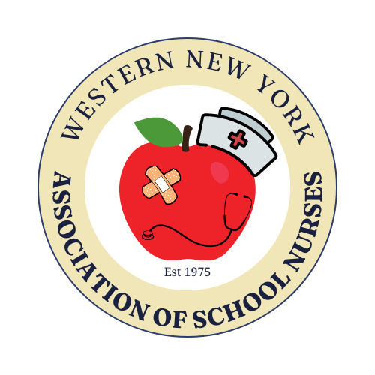
WESTERN NEW YORK ASSOCIATION OF SCHOOL NURSES
$1,000 SCHOLARSHIP APPLICATION
APPLICATION DEADLINE ~ Postmarked by May 1, 2026

Name: ___________________________________________________Date of Birth: _______________

Address:_____________________________________________________________________________

City/State/Zip:________________________________________________________________________

Home Phone: (___) __________________ E-mail: ___________________________________________

Name of High School __________________________________________ Phone: _________________

School Address: _______________________________City:__________________ Zip: _____________

Date of HS graduation: ______________________ GPA: ____________ Class rank: _______________

Name of Nursing Program you plan to attend:_______________________________________________
Must be a BSN (Bachelor of Science in Nursing 4 year) degree program in New York State.
**NOT: ECC, NCCC, or Trocaire or similar 2 year program

Nursing Student Status (check all that apply):
During the next school year, I will be enrolled ______ Full time ______ Part time

Tuition cost for the first year (do not include room/board): $ ____________________________________

Please indicate if you are receiving financial assistance (grants / scholarships / merit awards etc.) for the next academic year (or you may provide us with a copy of your financial aid package letter).

Funding source Amount Dates of assistance
________________________________________________________________________________________________________________________________________________________________________________________________________________________________________________________________________________________________________________________________________________________________________________________________________________________________________________________________________

I hereby affirm that all the information provided is true and any false statement will forfeit my qualification for the consideration of the scholarship. This application is the sole property of WNYASN. All information is strictly confidential and will not be returned.

________________________________________________ _________________
Applicant’s signature Date

The following items must be sent to the Scholarship Committee. Incomplete applications will not be considered.
● Copy of your acceptance letter from the college you plan to attend, showing your declared major.
● Signed above application
● Official high school transcript.
● Listing of extracurricular, church or community activities (sports, clubs, etc.) in which you have been involved. Volunteer and/or community services you have completed, work experience or internships you have had, awards/honors received, etc.
● Personal statement of 250 – 500 words on your goals and aspirations as they relate to your education, career and future plans. Explain why you are a qualified candidate and should be considered for this scholarship. Please explain any special considerations of which you feel this committee should be aware. Personal statements should be typed.
● Two references – one personal or professional (work reference) and one from a High School Teacher, School Counselor, Coach, School Nurse, or School Administrator. (The enclosed reference forms may be used.) ALL REFERENCES MUST BE AN ADULT.

Please mail your completed application to:

WNYASN Scholarship Committee
Sarah Insley, RN
14 Glencove Court
Orchard Park, NY 14127

PERSONAL / WORK REFERENCE
APPLICATION DEADLINE ~ Postmarked by May 1, 2026
To be filled out by a personal adult friend or professional work supervisor

Applicant’s Name:_____________________________________________________________________

- How long have you known the applicant? ____________________________________________

- In what capacity do you know the applicant? __________________________________________
_____________________________________________________________________________

- How would you assess the applicant’s character? Please circle one of the following:
Poor Fair Average Above Average Outstanding

- If you’re a friend please describe why you think the applicant is a well-rounded individual.
If you are a supervisor please describe how this applicant’s work ethic contributed to your agency.
_____________________________________________________________________________
_____________________________________________________________________________

- Why do you recommend this applicant for a Nursing Scholarship?
_____________________________________________________________________________
_____________________________________________________________________________

Name of person filling out this recommendation: (Please print) __________________________________
Title: _____________________________________
Work Phone: ______________________________ Home phone: _______________________________
Please mail this recommendation to:
WNYASN Scholarship Committee
Sarah Insley
14 Glencove Court
Orchard Park, NY 14127
SCHOOL PROFESSIONAL REFERENCE
APPLICATION DEADLINE ~ Postmarked by May 1, 2026
To be filled out by a High School Teacher, School Counselor, Coach, School Nurse, or School Administrator

Applicant’s Name:_____________________________________________________________________

- How long have you known the applicant? ____________________________________________

- In what capacity do you know the applicant? __________________________________________
_____________________________________________________________________________

- How would you assess the applicant’s character? Please circle one of the following:
Poor Fair Average Above Average Outstanding

- What is the applicant’s class rank?________________Grade Point Average?________________

- Why do you recommend this applicant for a Nursing Scholarship?
_____________________________________________________________________________
_____________________________________________________________________________
_____________________________________________________________________________

Name of person filling out this recommendation: (Please print) __________________________________
Title: _____________________________________
Work Phone: ______________________________ Home phone: _______________________________

Please mail this recommendation to:
WNYASN Scholarship Committee
Sarah Insley
14 Glencove Court
Orchard Park, NY 14127

